DVPR

1. 01_dvpr_introduction

* Stehen alle Infos drin, Bücher, …

2. 02_pm_introduction

* What is a project?
  + A project is a temporary endeavor undertaken to create a unique product, service or result
  + Why? To sustain business
  + Duration? End when objectives are reached or project is terminated
  + Size? Large or small, short or long, doesn’t mater
* Project Management: application of knowledge, skills, tools and techniques to project activities to meet project requirements
* Project is a success when:
  + Met Scope/Quality, Time and Cost goals
  + Satisfied the customer/sponsor
  + Project met its main objective
* Role of Project Manager:
  + Responsible of planning, scheduling, coordinating and working with people to achieve project goals
  + 97% of successful project were led by experienced project managers
* Skills a Project Manager need:
  + Body of Knowledge (knows what a project is and what he has to do)
  + Application area knowledge, standards and regulations
  + Environment knowledge
  + General management knowledge and skills
  + Soft skills
* What helps a project to succeed: user involvement, executive support, clear business objectives, emotional maturity, optimizing scope, agile process, project management expertise, skilled resources, execution, tools and infrastructure
* Program Management:
  + Program is a group of related projects managed in a coordinated way to obtain benefits and control not available from managing them individually
  + Program manager manages project managers
  + 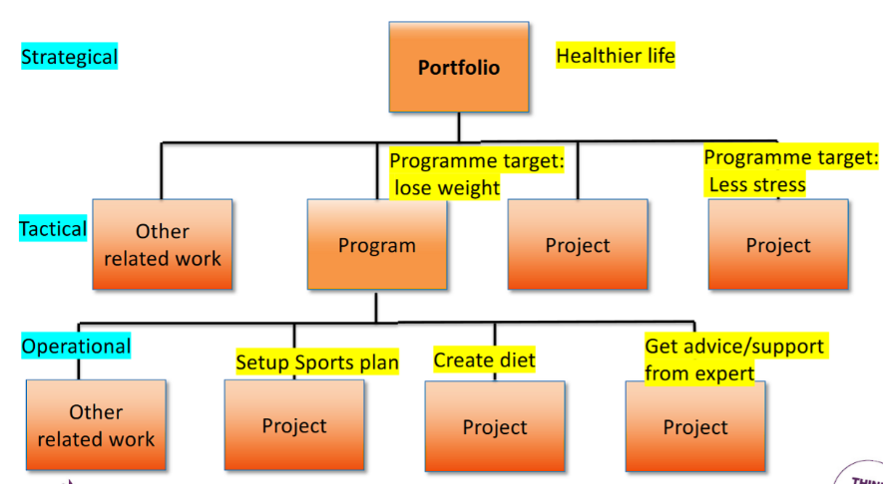Program example:
* Project Portfolio Management:
  + Organizations group and manage project and programs as a portfolio of investments that contribute to entire enterprise’s success
  + Portfolio managers help organizations make wise investment decisions

3. 03_pm_basics

* Project: think, do, close (think before you act)
* 4 major anchor points to manage a project:
* Scope:
  + Well-defined project scope is a necessity to ensure the success of the project
  + Clear vision, agreement on the outcome of the project
* How to successfully define a scope:
  1. Identify the project needs
  2. Confirm the objectives and goals of the project
  3. Clear project scope description
  4. Exceptions and acceptance
  5. Identify constraints
  6. Identify necessary changes
* Quality:
  + Means meeting the needs of customers (“fit for use”)
  + Can be checked by testing based on mutual approved test requirements by developer, user and project owner
* Time & Planning:
  + Think – Agree – Do/Act – Check – Deploy – Close
  + Planning must be continuous throughout the project, no plan can or should survive in its original form from the start of the project to the finish
* Money / Cost Management:
  + Process of estimating, allocating and controlling the costs
  + Allows to predict coming expenses in order to reduce the chances of it going over the budget
* 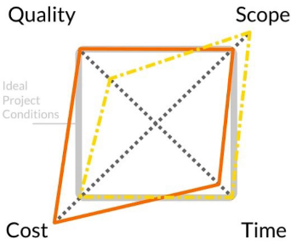4 points are in “Project Devils Square”
* Need to:
  + Project organization to run the project (Demand, Supply, Project Owner)
  + Communication
  + Manage risks and issues
  + Manage changes

4. 04_pm_basics_2

* Work Breakdown Structure (WBS):
  + Is a deliverable-oriented hierarchical decomposition of the work to be executed by the project team to accomplish the project objectives and create the required deliverables
  + Organizes and defines the total scope
  + Decomposed into work packages
* Product Breakdown Structure (PBS):
  + Tool for analyzing, documenting and communicating the outcomes of a project, forms part of product-based planning
* Complementary: PBS 🡪 WBS
  + PBS is identical in format of WBS, but is a separate entity, is used at a different step in planning process
  + PBS precedes the WBS and focuses on cataloguing all the desired outputs needed to achieve goal, feeds into creation of WBS, identifies the task and activities required
  + In a nutshell: PBS defines where you want to go, WBS tells you how to get there
* Example: breakdown of mountain bike
  + PBS:
  + 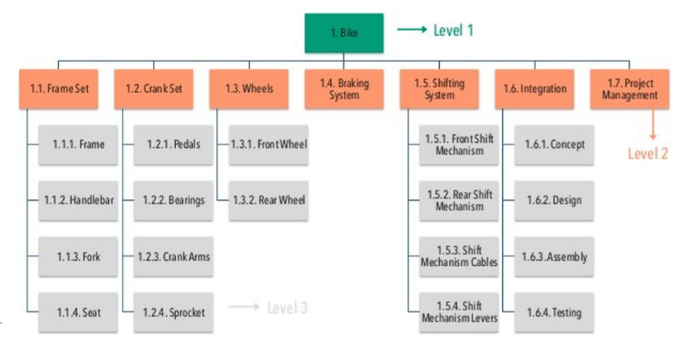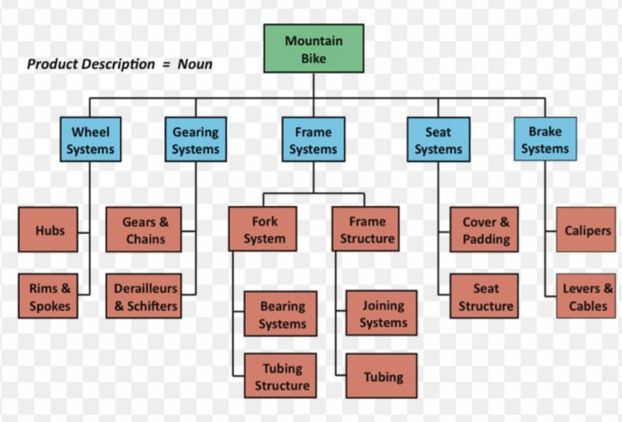WBS:
* *Presentation then tells how to create a PBS / WBS diagram*
* Quality review technique:
  + Structured procedure designed to access whether a deliverable is ‘fit for purpose’ or conforms to requirements
  + Can be invoked at any point during project

5. 05_pm_methods_and_tools

* RICAD – Logging of what is happening
  + Risks
  + Issues
  + Changes
  + Actions
  + Decisions
* Risks:
  + Set of events that will have an effect on achieving the project goals
  + Uncertain event will have a positive or negative effect on project
  + Risk Log provides a record of identified risks relating to project, including status and history. Used to capture and maintain information on all the identified threats and opportunities
* Issues:
  + Term used to cover any concern, query, request for change, suggestion or off-specification raised during the project
  + Issue Log capture and maintain information of all issues being formally managed, monitored by Project Manager
* 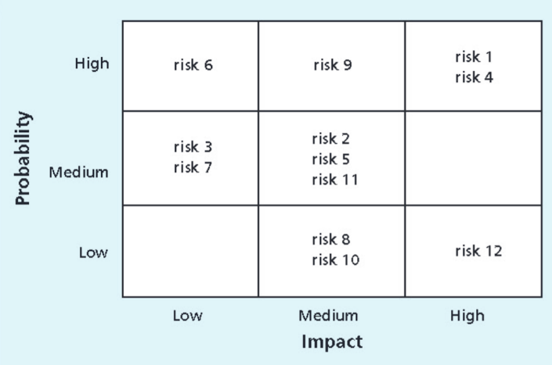Risks can be monitored by a Probability/Impact Matrix
* Changes:
  + Scope control is process of managing the scope of project when changes happen, need to set up change control process
  + When changes are uncontrolled, it’s a scope creep
  + Change management is important. Project Manager must examine proposed change and determine effect on project
  + Changes can be anything (Scope, Quality, Timelines, Money)
  + Captured in Change log
* Decisions:
  + Captured in decision log
  + Must be captured to avoid later discussions / scope creeps

6. 06_pm_planning

* Importance of Project Schedules:
  + Managers want project finishing on time
  + Time has least amount of flexibility, passes no matter what happens
  + Schedule issues are main reason for conflicts
* Project Time Management Process:
  + Planning schedule management: policies, procedures and documentation for planning, executing and controlling
  + Defining activities: specific activities to produce project deliverables
  + Sequencing activities: identifying and documenting the relationships between project activities
  + Estimating activity resources
  + Estimating activity durations
  + Developing the schedule: analyzing activity sequences, activity resource estimates and activity duration estimates to create the project schedule
  + Controlling the schedule: controlling and managing changes to project schedule

7. 08_agile_principles_and_mindset

* Agile Project Management: iterative development methodology that values human communication and feedback, adapting to changes and producing working results
* Why agile?
  + Different projects – different methods
  + Better in complex projects with fast-moving environments
* “Normal” project vs. Agile project:
* 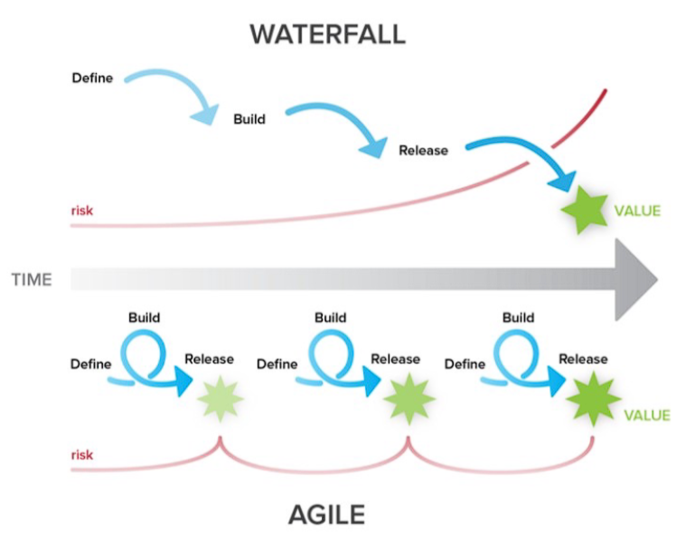Advantages of agile:
  + Increase ROI (return of invest): continuous flow and focus
  + Deliver reliable results: engage customers
  + Expect uncertainty: manage with iterations and adaption
  + Unleash creativity and innovation: individuals make the difference
  + Boost performance: accountability for results
  + Improve effectiveness: practices, processes, strategies
* 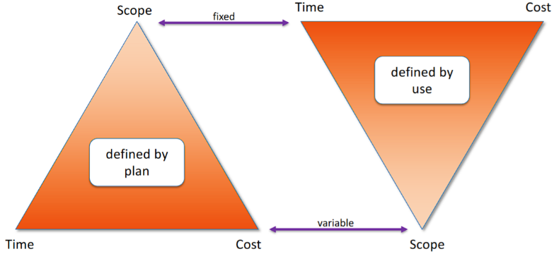Agile Triangle:
* Agile Manifesto:
  + Individuals and interactions over processes and tools
  + Working software over comprehensive documentation
  + Customer collaboration over contract negotiation
  + Responding to change over following a plan
* Agile Methodologies:
  + Scrum
  + Extreme Programming (XP)
  + Lean Product Development
  + Kanban
  + Feature-Driven Development
* Scrum
* Three pillars:
  + Transparency
  + Inspection
  + Adaption
* 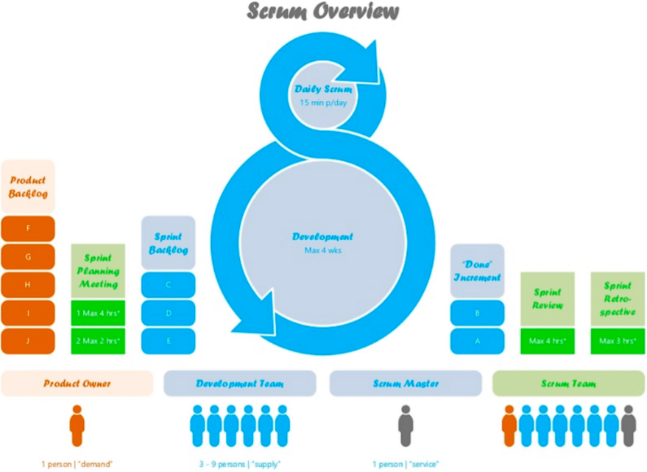Scrum overview:
* Sprint:
  + Timeboxed 1-4 weeks (most 2 weeks)
  + Mini project
  + Scope defined at beginning
  + Work will be done based on items on sprint backlog
* Scrum Roles:
  + Product Owner (demand): Product backlog, Business Value, Contact person for team (i.e., the customer)
  + Development Team (supply): Estimations, Delivers releasable increments, Interdisciplinary, Self-organizing
  + Scrum Master (service): Ensures process, Helps removing impediments, Moderation, Coaching
* Product Owner:
  + Product Owner responsible for maximizing the value of the product and work of the Development Team
  + Responsible for managing Product Backlog
* Product Backlog:
  + List of everything which might be needed for the product (Backlog Items)
  + Single source of requirements
  + Product Owner puts new Backlog Items into Product Backlog
  + Order of Product Backlog defines “importance” and thus steers which one to do next
* Sprint Planning Meeting:
  + Participants: Scrum Master, Product Owner, Development Team
  + Timeboxed: 2 hours per 1 week sprint
  + Scrum Master teaches how to stay in timebox
  + Goals: which work to complete in the next sprint and how?
  + Team decides based on capacity and velocity how much work can be done until end of next sprint
  + Outcome: Sprint Goal and Sprint Backlog
* Daily Meeting:
  + No Management reporting meeting
  + Timebox: 15 minutes
  + Questions: What did I do, what will I do, are there any Issues
  + No detailed discussions
  + Team getting informed about progress
* Review Meeting:
  + Participants: Scrum Master, Product Owner, Development Team
  + Timebox: 1 hour per 1 week
  + Team demonstrates results
  + Product Owner accepts or not accepts results
  + Probably new product Backlog Item occur
* Sprint Retrospective Meeting:
  + Most important Meeting
  + What went wright / wrong
  + Inspect and Adapt
  + Plan improvements
  + Scrum Master moderates
* Extreme Programming
* Core Values:
  + Simplicity
  + Communication
  + Feedback
  + Courage
  + Respect
* XP Roles:
  + Coach: similar to Scrum Master
  + Customer: Similar to Product Owner
  + Programmer: write and implement code
  + Testers: help customer to define acceptable tests
* Lean Product Development:
  + Eliminate waste
  + Empower the team
  + Deliver fast
  + Optimize the whole
  + Build quality in
  + Defer decisions
  + Amplify learning
* Kanban: Signboard to visualize workflow
* Feature-Driven Development (FDD)
  + First building an overall model
  + Build a feature list, plan the work
  + Design and build features

8. 09_agile_value_driven_delivery

* Reason project exist is to generate business value
* Value Driven Delivery: focus on delivering value
* “Which choice will add the most value for the customer?”
* Aim to deliver highest value portions of the product ASAP (Eat your dessert first)
* Minimize waste:
  + Unclear requirements
  + Partially done work
  + Extra processes
  + Extra features
  + Task switching
  + Waiting
  + Defects
* Financial Assessment Metrics:
  + Return of Investment (ROI): ratio of the benefits from an investment to the money invested in it, higher equals better
  + Net Present Value (NPV): present value of a revenue stream (income minus costs), higher equals better
  + Internal Rate of Return (IRR): discount rate at which the project inflows and outflows are equal, higher equals better
  + Earned Value Management (EVM): measuring the cost, scope and time performance by comparing planned value, estimated costs with actual costs and earned value
* Multiple Prioritization Schemas:
  + Simple: Prio 1, Prio 2, Prio 3
  + MoSCoW: Must have, Should have, Could have, Would like to have, but not this time
  + 100 Point Method: each stakeholder has 100 Points to vote for the most important requirements
* Minimal Viable Product (MVP)
  + Package of functionality that is complete enough to be useful, but not represent the whole project
* Verifying and Validating Value
  + Validation: Are we building the right product?
  + Verification: Are we building the product, right?
  + 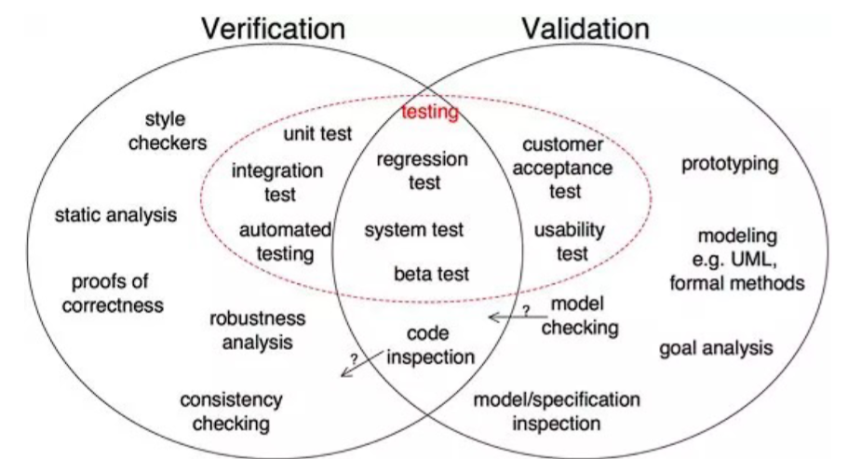Communication is important

9. 10_agile_stakeholder_engagement

* Principles of Stakeholder Engagement
  + Get the right stakeholders / stakeholder analysis
  + Cement stakeholder involvement
  + Actively manage stakeholder interest
  + Frequently discuss what “done” looks like
  + Show progress and capabilities
  + Candidly discuss estimates and projections

10. 12_agile_adaptive_planning

* Timeboxing: fixed cost and timeframe
* Decomposing requirements:
  + Work that cannot be accurately sized, estimated and planned 🡪 need to decompose or break down
* User Stories:
  + short, simple description of a feature, from the perspective of the person who desires the new capability
  + Small chunks of business functionality within a feature
  + Agile teams break down work into user stories
  + Will be put on the prioritized product backlog
  + Format: As a <type of user>, I want <goal> so that <reason>.
* User stories should follow INVEST acronym:
  + Independent
  + Negotiable
  + Valuable
  + Estimable
  + Small
  + Testable
* Story points:
  + Team should own the definition of their story points
  + Story points estimates should be all-inclusive
  + When aggregating estimates, the totals do not need to match
  + Complexity, work effort and risk should be included in estimates

11. 13_agile_problem_detection_and_resolution

* Technical debt
  + Backlog of work that is caused by not doing regular clean-up, maintenance and standardization
  + Backlog od things that should be done to make things easier
  + Solution: Refactoring
* Detecting problems: Lead Time and Cycle Time
* Lead Time:
  + How long something takes to go through the entire process, e.g., from design to shipping
  + Is a tool to identify and diagnose problems
* Cycle Time:
  + Subset of Lead Time
  + How long does something take through part of the process, e.g., from coding to testing
* Cycle Time = WIP / Throughput
  + WIP = Work in progress
  + Throughput = amount of work that can be processed through a system in a given amount of time (what was done in an iteration)
* Variance Analysis: accept variance or take action?
* Best practice:
  + Do not micromanage, most variances are quite ok and normal
  + Look for external triggers
  + Decide: is it a common cause 🡪 take no action; is it a special cause (e.g., external trigger) 🡪 take action

12. 14_agile_continuous_improvement

* Kaizen: Japanese process for continuous improvement, means “change for better”
* Basis for agile way of making small improvements on a daily base
* Focuses on encouraging the team frequently and implement small incremental improvements
* It is a principle, not a standardized framework
* Kaizen key to-do’s:
  + Improve the quality of your products / processes
  + Review the cost live cycle
  + Improve efficiency and productivity
  + Use training to develop people
  + Lead people to their best
  + Break down barriers
  + Give people autonomy & responsibility
* PDCA – Cycle: four-step model for carrying out change
* No end, should be repeated over again 🡪 continuous improvement
* Procedure:
  + Plan: recognize an opportunity and plan a change
  + Do: test the change
  + Check: review the test, analyze the results and identify what you have learned
  + Act: take action based on what you learned
* If change did not work, go through cycle again to test something new
* If successful, apply it, write down findings, begin cycle again
* Process Tailoring: tailor a process to the current needs
* Not creating a completely new process, only tailor parts of it
* Changes must be documented
* Can boost flexibility and speed
* Risks:
  + Takes time
  + Can get out of hand
  + Experience is needed
* Fail Fat / Fail Forward (Learn by Doing): Do not waste too much time on lesson lend, document failures and quickly continue
* Continuous learning experience
* Adapt yourself, do not make same mistakes over again
* Individual process
* Perpetual beta (“banana principle”): buy the product before it reaches the final state
* Development continues after purchase
* Customer finances the product
* Most common in software industry
* Alpha-/Beta-version of software application
* Six Sigma: management toll for process optimization
* DMAIC Cycle:
  + Define: identify processes which could be optimized
  + Measure: measure how the process performs until now
  + Analyze: analyze why the process is executed in its current state
  + Improve: try to find improvements which could optimize the process
  + Control & Implement: Control the new process and evaluate the impact of the change concerning to price / quality / time
* Project Pre-Mortems: exercise that aims to identify possible failure points on a project before they happen so that we can avoid or minimize those risks
  + Especially valuable on long-running projects, because more changes can happen
* Retrospective: what worked well, what did not work well, what action can we take to improve our process going forward
* 5 steps:
  1. Set the stage: to eliminate awkwardness in team, set stage as a game to make people comfortable
  2. Gather data: capture information from last sprint, wins and failures
  3. Generate insight: get more insight in information and work on possible solutions
  4. Decide what to do: create action items to work on
  5. Close retrospective